Project Development Phase
ACL Access Control Test
Date | 30 September 2026
Team ID / Project ID | SWTID-2026-8678
Project Name | Script-Controlled ACL – Restrict Record Access Based on Field Value
Maximum Marks | 10 Marks

ACL Performance Testing:
Project team shall fill the following information to demonstrate the implementation and validation of the Script-Controlled ACLs in ServiceNow.
S.No. | Parameter | Screenshot / Values
1 | User and Role Creation | EEE User created. Custom roles bb1, bb2, bb3 and bb4 created and assigned as required. Screenshot to be attached.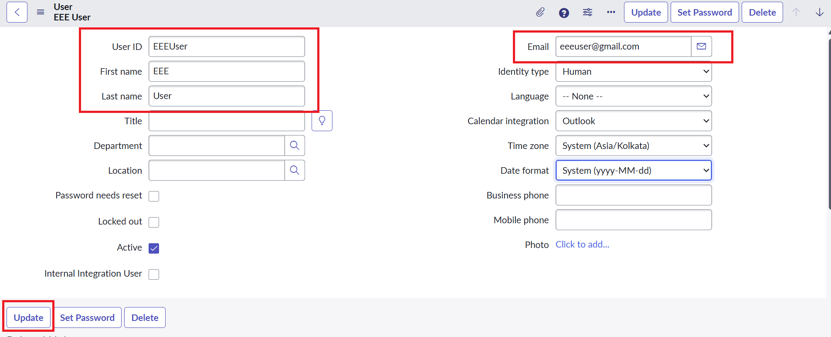
2 | Custom Table and Data | Table: u_institution_details. Fields include Student Roll Number, Student Name, Faculty Name, Branch, Email, Phone Number and Description. Branch values: ECE, EEE, CSE.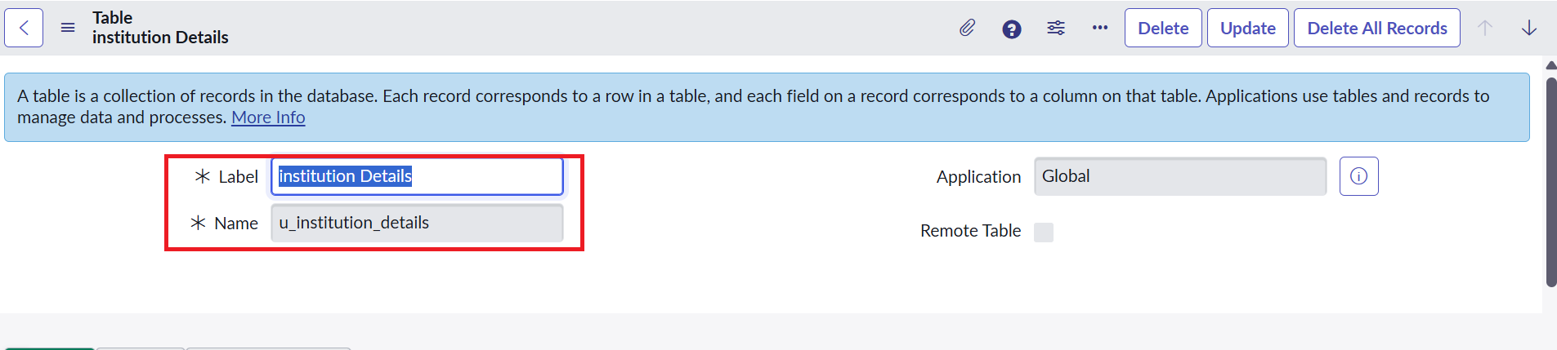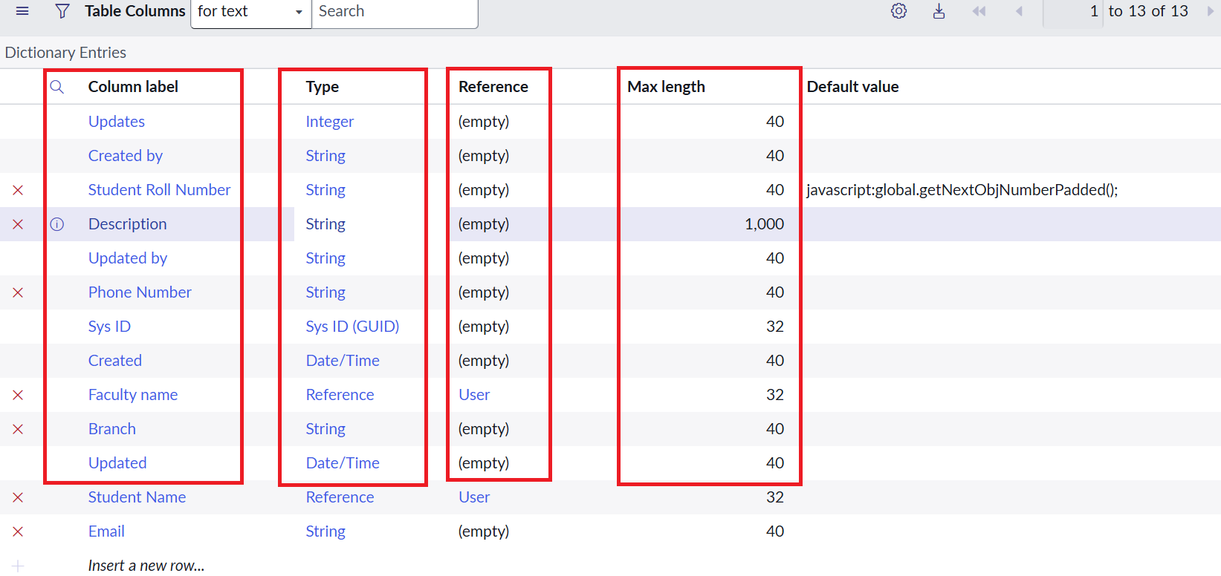
3 | Read ACL | Record Read ACL configured for u_institution_details. bb1 required; EEE branch condition applied; Admin retains full access.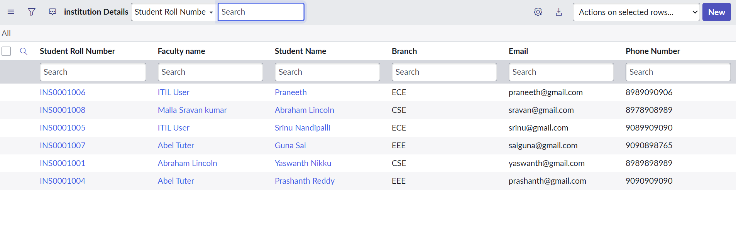
4 | Create ACL | Record Create ACL configured for u_institution_details. bb2 required.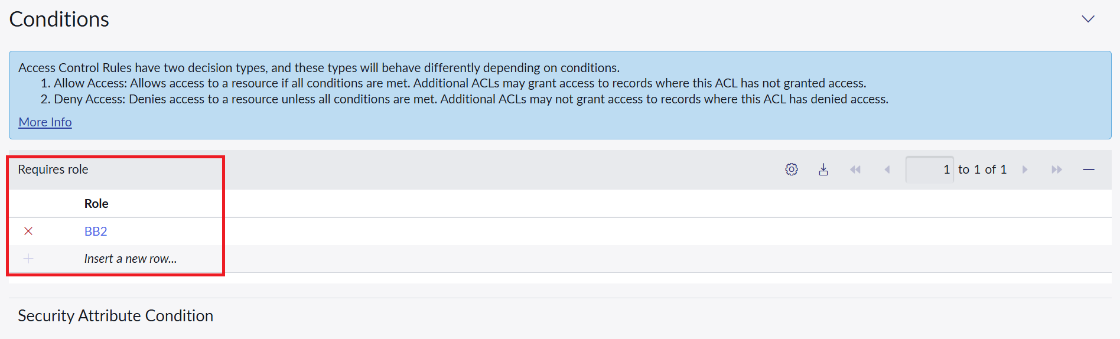
5 | Write ACL | Record Write ACL configured for u_institution_details. bb3 required.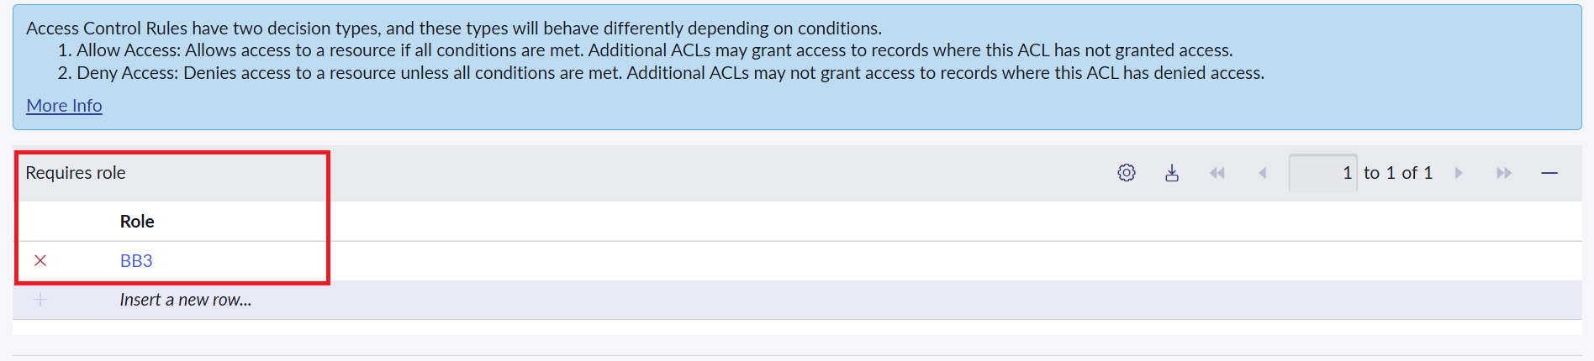
6 | Delete ACL | Record Delete ACL configured for u_institution_details. bb4 required.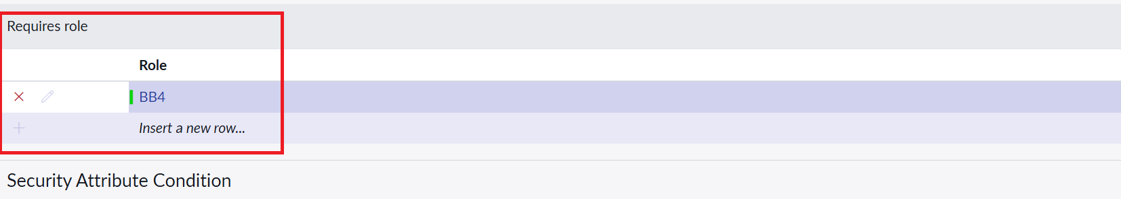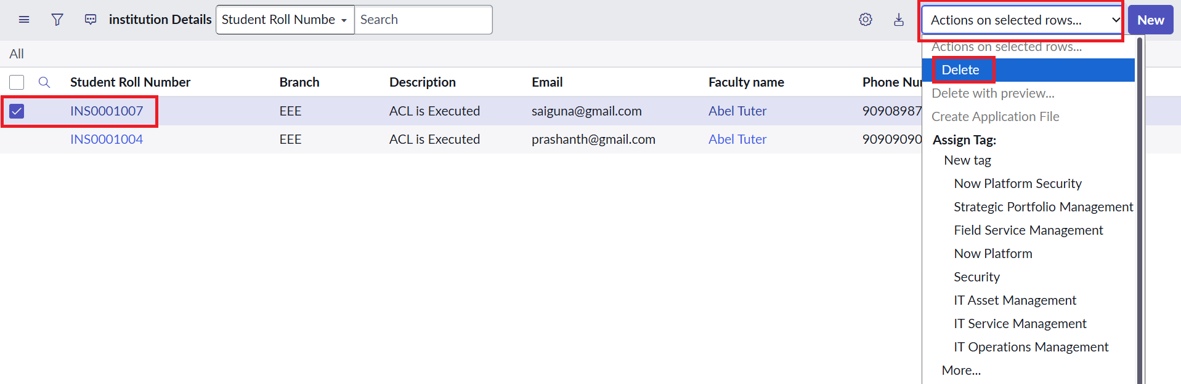
7 | Access Verification | Impersonation testing: bb1 user can view EEE records; users without required roles are denied; Admin can access all records.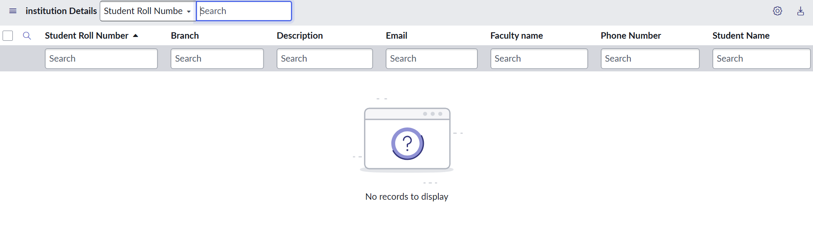
8 | CRUD Verification | Users with bb1+bb2 can create; bb1+bb2+bb3 can edit; bb1+bb2+bb3+bb4 can delete, according to the project configuration.
9 | Script Validation | ACL script checks admin access, checks the bb1 role, and denies access for other users.
10 | Overall Result | Record-level security is enforced through roles and the Branch field, restricting unauthorized viewing, creation, modification and deletion.

Expected Outcome:
The ServiceNow ACL configuration should correctly enforce access permissions for the Institution Details records based on user roles and the EEE branch condition, while allowing administrators full access.

